|  |  |  |
| --- | --- | --- |
|  | **GUJARAT TECHNOLOGICAL UNIVERSITY**  Chandkheda, Ahmedabad  Affiliated |  |

Sardar Vallabhbhai Patel Institute of Technology

Vasad-041

A

Project Report

On

**Internet of Things**

Under the course of

**DESIGN ENGINEERING – 1A (2130005)**

B. E. II, Semester – III

**(Information and Technology Branch)**

***Submitted by:***

Group ID: 5295

|  |  |  |
| --- | --- | --- |
| **Sr.** | **Name of student** | **Enrolment No.** |
|  |  |  |
| 1 | Kaushiki Kansara | 160410116048 |
| 2 | Karansinh Matroja | 160410116055 |
| 3 | Jeet Meghpara | 160410116056 |
|  |  |  |
|  |  |  |

|  |  |
| --- | --- |
| **Prof.**  **Amit Kariyani**  **(Faculty Guide)** | **Prof.**  **N.V. Shah**  **(Head Of Department)** |

**Academic year**

**(2017-2018)**

|  |  |  |
| --- | --- | --- |
|  | **GUJARAT TECHNOLOGICAL UNIVERSITY**  Chandkheda, Ahmedabad  Affiliated |  |

**CERTIFICATE**

This is to certify that the students namely, **Kaushiki Kansara (160410116048), Karansinh Matroja(160410116055), Jeet Meghpara(160410116056)** of ***B. E. ( Information Technology) Semester III*** have successfully completed the course work and related tasks for the course of **Design Engineering 1A (2130005)** during the academic term ending in the month of October 2017.

Date: 13-10-2017

Place: SVIT VASAD

**Prof. Mr. Amit Kariyani Prof. Mrs. N.V. Shah**

(Faculty in Charge) (Internal Examiner/HOD) (External Examiner)

Table of Contents

1. Introduction 4

1.1. About Team Member 4

1.2. About Internal Faculty 4

2. A.E.I.O.U. Canvas 5

2.1. A-Activity 5

2.2. E-Environment 5

2.3. I-Interaction 5

2.4. O-Objects 6

2.5. U-Users 6

3. Empathy Mapping 8

3.1. Users 8

3.2. Stakeholders 8

3.3. Activity 8

4. Ideation Canvas 10

4.1. People 10

4.2. Activities 10

4.3. Situation/Context/Location 10

4.4. Props/Possible Solution 11

5. Product Development Canvas 12

5.1. Purpose 12

5.2. People 12

5.3. Product Function 12

5.4. Product features 12

5.5. Components 12

6. Mind Mapping 14

# Introduction

Imagine a world in which every device in the home, workplace and car are connected. A world where the lights automatically turn on when the car approaches the driveway, the [coffee starts brewing](http://www.technologyguide.com/feature/coffee-tech/) when the morning alarm goes off and the front door automatically unlocks when approached by a member of the household, but stays locked when a stranger arrives on the front step. That is the type of world the Internet of Things can create.

## About Team Member

In our group, there are 3 members named **Kaushiki Kansara (160410116048), Karansinh Matroja (160410116055),** and **Jeet Meghpara (160410116056).**

## About Internal Faculty

In our group, there is one Internal Faculty guide named **Prof. Amit Kariyani** who is very good and experienced teacher in Design Engineering Subject. He always gives us advice about what to do and what is not.

# A.E.I.O.U. Canvas

There are five topics that comes under AEIOU canvas. They are:

## A-Activity

* Communication
* Report
* Overview
* Report
* Enjoyment
* Case study
* Photography
* Lunch

## E-Environment

* Summer
* Office
* Windows
* Automation
* Without Interruption
* Convenience
* Smooth
* Speed

## I-Interaction

* Admin
* Manager
* Employee
* Components
* Fan
* Air-conditioner
* Efficient performance

## O-Objects

* Controlling Device
* Electrical Appliances
* Internet
* Wi-Fi Connection
* Sensors
* Cloud Storage
* Server
* Bluetooth

## U-Users

* Engineers
* Senior Citizens
* Officers
* Doctors
* Businessmen
* Employers
* Students
* Teachers

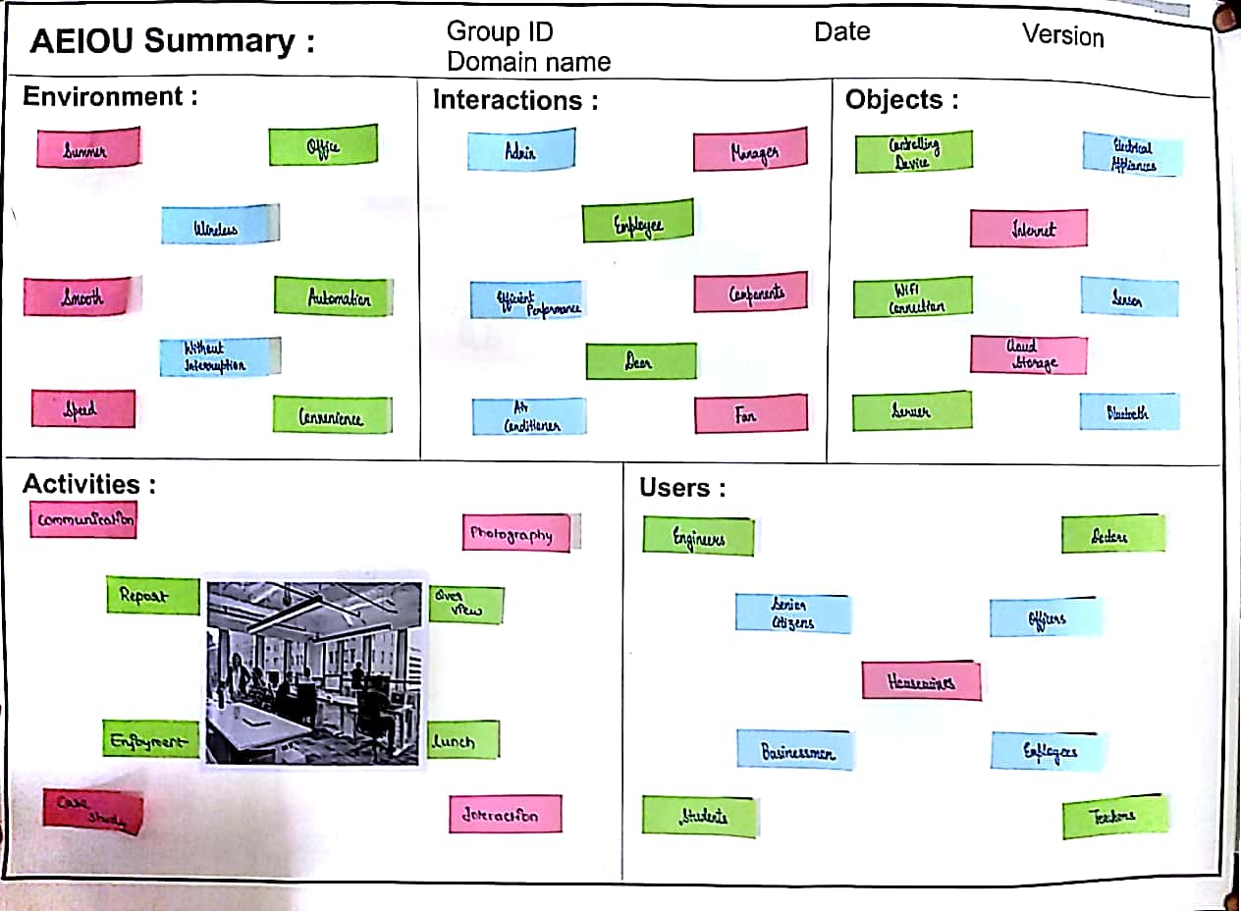

# Empathy Mapping

Here we are going to explain Users, Stack Holders and Activity. And hear story boarding which have one happy story and one sad story.

## Users

* Students
* House Wives
* Doctors
* Senior Citizens
* Teachers

## Stakeholders

* Manufacturers
* Engineers
* Servants
* Businessmen
* Dealers

## Activity

* Easy Availability for Applications
* Home Security
* Multi-Tasking
* Data Capture
* Automation
* Controlling Appliances
* Saving Electricity

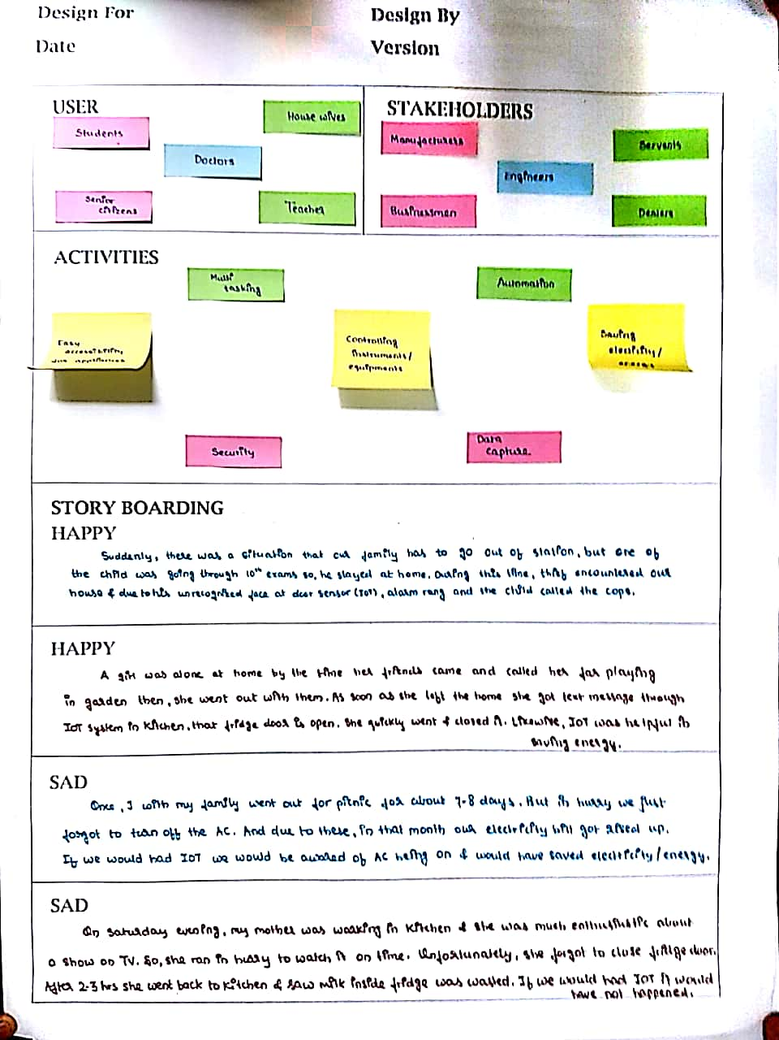

# Ideation Canvas

We have described activities of people, situation and location and the problems which they face. This canvas is very helpful to reach near goal as it helped us to know the areas on which we need to focus.

## People

* Senior Citizens
* House Wives
* Businessmen
* Engineers
* Students
* Teachers
* Doctors

## Activities

* Local Sensing
* Data Capture
* Home Security
* Automation
* Home Security
* Controlling Devices
* Saving Electricity
* Multi-Tasking

## Situation/Context/Location

* Home Invasion
* Safety
* Car Parking
* Smart Metering
* Smart Farming
* Gardening
* Industry
* Living room
* College

## Props/Possible Solution

* Controlling Devices
* Sensor
* Internet Connection
* Wi-Fi
* Electrical Appliances
* Cloud Storage
* Server
* Connectors
* Bluetooth

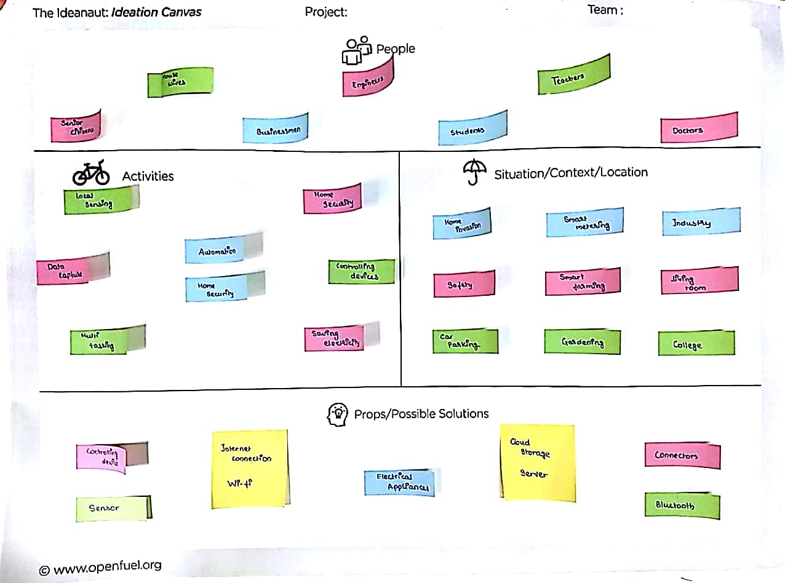

# Product Development Canvas

This Canvas is helpful to understand the purpose, product experience and function of our project.

## Purpose

* Easy Handling
* Automation
* Smart Metering
* Energy Saving

## People

* House Wives
* Senior Citizens
* Students
* Engineers
* Doctors

## Product Function

* Manages Range of Devices: As every component is connected to the Internet.
* Environmental Monitoring: Can be implemented using Cameras.
* Stores Personal Data: 24x7 data capture.
* Home Automation: Useful for Senior Citizens.

## Product features

* Saves Resources: Reduces Resources wastage.
* Security: Prevent unauthorized access to main doors.
* Command & Control: Overall control in your hands.
* Increases Task Efficiency: By the use of algorithms.
* Drives down Costs: Smart Metering.

## Components

* Controlling Devices
* Sensors
* Server
* Internet
* Wi-Fi Connection
* Connectors
* GPS, Bluetooth
* Cloud Storage
* Electrical Appliances

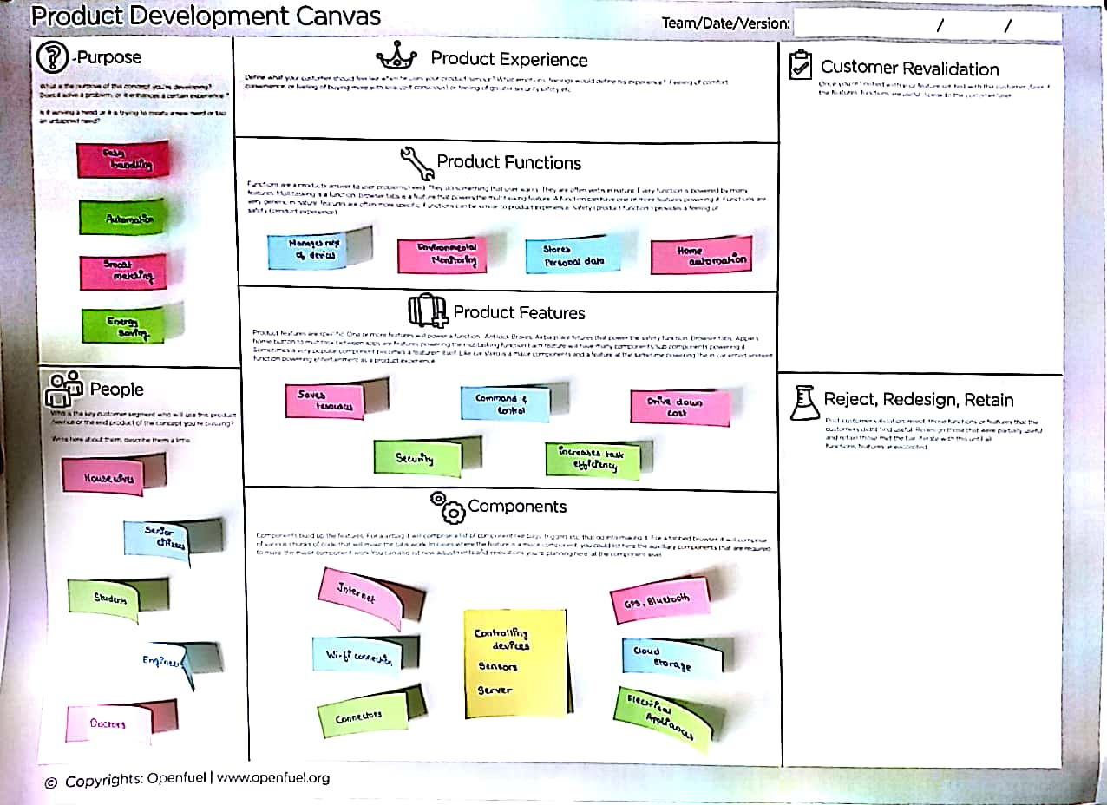

# Mind Mapping

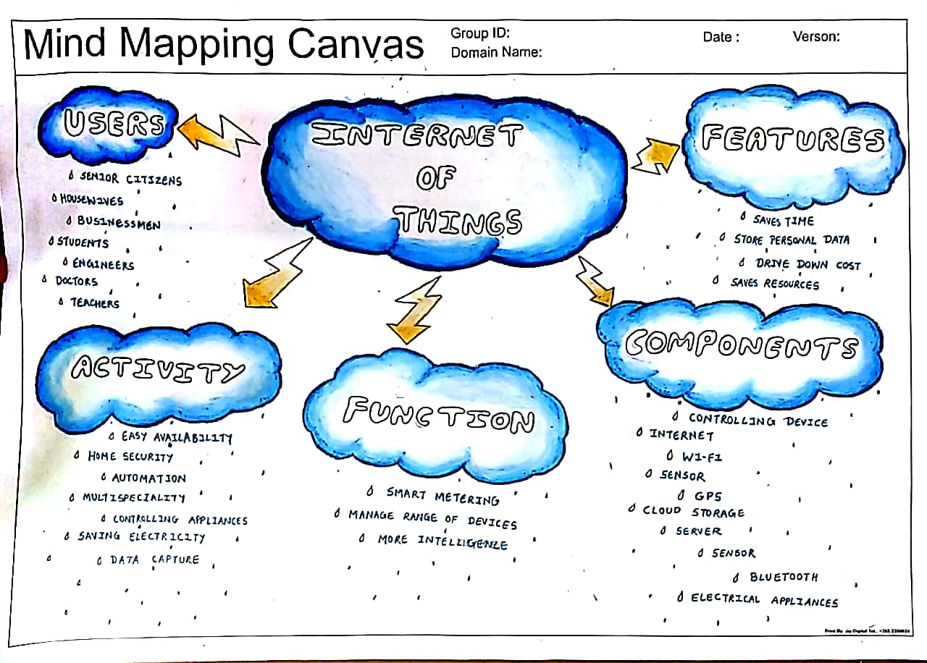

There are 5 features in the Mind Mapping Canvas.

* Users
* Activity
* Function
* Features
* Components